BioLecTracer (BLT)
The Easy ECG
Active device intended for recording, processing and view diagnostic images.
Medical Devices Directive 93/42/EEC Rule12 MDA example p35
THIS maybe A COPY OF WHAT YOU HAVE DONE SO FAR from the Read me
Click on LicenceAgreement.doc and read it
(You have to accept later)

It is recommended you PRINT this manual before preceding any further and then read from it.

You will need to know your screen area!
To find out what you are using - Right click on your desktop - click Properties - click Settings and see what you Screen area is set at.
The most common and best for BioLecSoftware is 1024 by 768. If it is bigger that's OK.
If it's lower then you will need to upgrade your computer or software to use BioLec fully. Try moving the slider to the right if the numbers go bigger then click apply and then click OK. You may have to restart the computer.

To install BioLecTracer

Copy the whole Directory (BioLec) from the CD to your (C:) Drive
To do this
Right click on (!BioLecTracer) on the CD
Slide down and click (copy)
NOW Right click your (C:) drive
Slide down and click paste
Now navigate to (C:/!BioLecTracer/Setup)
And double click (setup.exe Application)
Follow instructions on screen
Accepting the defaults
"Its very quick"
Thank you for obtaining (hopefully buying) this BioLec Equipment.
You should now be reading this from a printout or from your C drive C:/BioLec/Manual/manual

1. Setting up your BioLecHardware (BLH)

After unpacking you should have
1 CD (probably still in your CD drive) take it out now and keep it safe
1 BLH unit (A red heart shape)

1 small bottle containing a clear liquid,
This is saline solution (Actually saline is just Salt Water)
Replenish with ¼ teaspoon salt to a pint of water
Submerge and squeeze bottle to suck in saline.

Take off the blue battery cover on the bottom of your BLH
by removing the cross headed screw in the centre.
Install two new PP3 batteries.
(Batteries should last for some 1000 traces.
(Low battery protection software is incorporated))
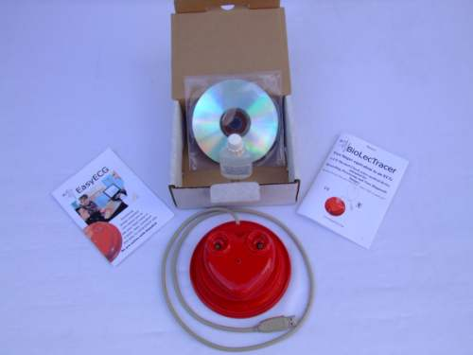
Replace cover taking care not to over-tighten.

2. Read before
plugging in the BLH for the first time
Different computers install HIDs (human interface device) in different ways but all are simple.
Have a clear windows desktop and watch your mouse pointer carefully as you Plug in the BLH for the first time.
You should see "Found new hardware" and the name BioLecTracer. This should only be on screen for a few seconds and be replaced by

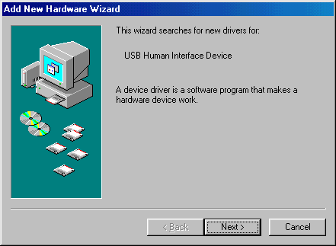
Click Next and follow instructions. You should only have to do this once.
“Some computers do it ALL automatically.”

3. Running BioLec Software

Click START “On your windows desktop menu bar”
Slide up then Slide off programs
And find the icon BioLec "It should be at the bottom"
"You can Create a short cut and or then drag and drop it onto your desktop"

I will assume you have put it on your desktop “that’s the software installed”

Double click the Icon on your desktop
The first thing you should see is a disclaimer screen.
If you accept the Licence agreement and conditions then
Click the bar to continue.

I suggest you resize this document to the bottom and have the BioLec screen at the top so you can read it as we go or print it first.

4. Taking your first trace
NO direct contact with the 2 silver electrodes is best
Fingers should be relatively clean and free from grease.
Having saline solution under fingernails is BEST

The electronics are very sensitive and any movement of the body will give erroneous signals so keep as still as possible.
Some windows background applications can interrupt the taking of a trace if so disable them.
Very long fingernails may be a problem.
(Larger extension pots are available and are useful for the younger child and sleeping babies)

Put some saline solution in the POTS of the BLH unit
(Do NOT fill to the top leave room for your fingertips)
Click START and note a delay before trace starts.
Click Abandon
You can click Abandon at any time during the taking of a trace.

Click start and quickly
Put Left index finger in Left-pot
(will work with any finger of LEFT hand)

And Put Right index finger in Right- pot.
(will work with any finger of RIGHT hand)

Only fingertip contact with the saline solution is required
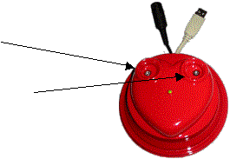
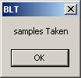
When the trace has completed you will be presented with

Remove fingers and Click OK or press ENTER on the keyboard

Congratulations first trace taken

When you start another trace the last trace is deleted
So if you want to keep it. Save it first.
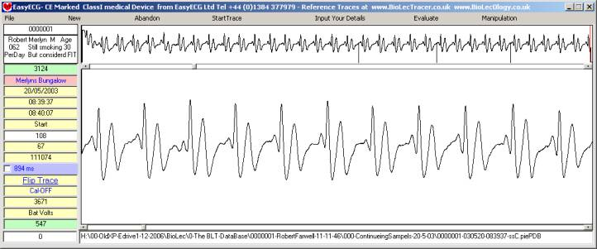

Understanding the fundamentals of the display
The top viewing screen displays 30 second’s of the trace taken.
15000 samples @ 500 per second
Every cycle of the heart produces a paten of the electricity or heartbeat.
Within the top trace 35 heart beats can be counted,
This equates to 70 in one minute.

A normal heart rate is accepted to be 60 to 70
The bottom screen displays any 10 second’s of the top trace.
I need to briefly introduce you to ECGs (Electrocardiograph’s)
Until NOW the only way to see a trace of a heart beating was by carrying out a costly, time consuming ECG.
The first ECG was produced around 1890 and evolved up to 1965. But in order to get ANY sensible readings in those days it was found that you had to have some 10 connections on the body, 6 being very close to the heart, 3 of the 4 limb leads are connected via meg-home resistors that provides a base line to get any usable result. That was also providing that you multiplexed or summed the signals from different connections and used different connections to denote different parts of the trace. Ending up with only a representation or montage.

Read More at www.biolecology.co.uk

The picture below is a section of a rhythm strip from my ECG

I show the method employed since 1920 to identify each wave, that is P. Q. R. S. T. and end of T wave.
This method was ill conceived as it cannot allow accurate pinpointing and indeed the “end of T wave” is disputed!
The P wave is accepted to be the start of a heartbeat BUT because it is not always easily identified on an ECG, the heart rate is calculated using the RR interval. The trace is printed out onto 25ms graph paper. The trace below has 4x25ms squares between R waves, so this RR = 60bpm approximately.
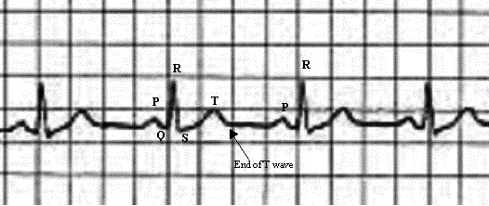
The equivalent BLT (BioLecTrace)

In order to allow for direct comparison I identify the equivalent waves with the same Letters PQRST except the “end of the T wave” when I identify it as the U wave, (any ECG U wave becomes a V wave).

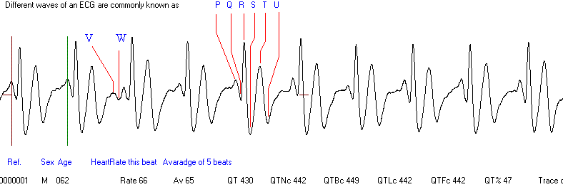

5. Viewing & measuring the Bottom trace.
Click or click & hold on right end of Top Scroll Bar
You will note that the slider on the top bar moves to the right and an enlarged view of the top trace scrolls across to the left in the bottom view pain!
Click or click & hold on the LEFT end of Top Scroll Bar
You will note that it moves back
Now Click or click & hold just to the right side of slider (NOT at the end) of Top Scroll Bar
You will note that it’s a finer movement
Now manipulate the trace so that any P wave dissects with the red marker on bottom display
To make the crosshairs visible check the blue box
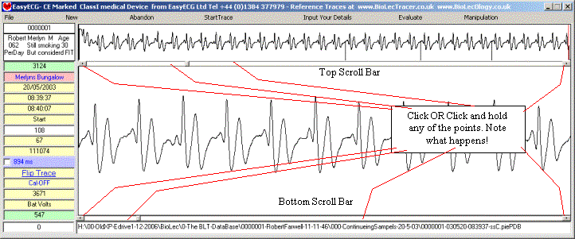

Click or click & hold on right end of Bottom Scroll Bar
You will see a green marker moving across from the left (the trace will not move)
Now manipulate the green marker so that it dissects with the next P wave.
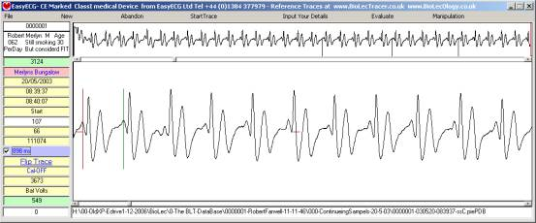

The heart rate can now be read.
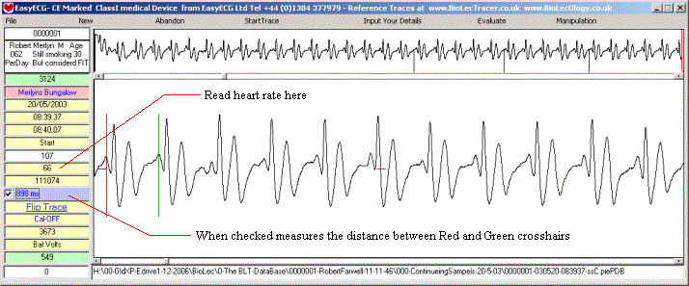
Click, or click and hold on either end of scroll bar (Just so you can see what happens.)
You can also click and drag the small scroll point.

Please have a little play around to get used to it.
Try saving & loading in the normal windows way Click File etc
Try swapping your hands halfway through taking a trace and note that the trace is now upside-down.

Please view www.EasyECG.com & www.BioLecOlogy.com

Caring for your BioLecHardware
Not a lot to do!
Keep clean and wipe off any saline spillage using a soft absorbent cloth
Operating temp 10 to 25 c
Although electronics need NO maintenance and are potted don’t drop or submerge in water.
Don’t kink leads

BLT an Active device intended for recording, processing and view diagnostic images only.
Medical Devices Directive 93/42/EEC Rule12 MDA example p35

That’s all for now please see
www.EasyECG.com
For FREE up dated manuals, as they are compiled and become available.
This equipment may be affected by electromagnetic interference.
Also BioLecTracer may affect other electrical equipment in the close vicinity.
If such effects are suspected either switch off the offending equipment or
increase the distance between the affected equipment and that
suspected of causing the interference.

